You have an Azure Virtual Desktop deployment.  
Many users have iOS devices that have the Remote Desktop Mobile app installed.  
You need to ensure that the users can connect to the feed URL by using email discovery instead of entering the feed URL manually.  
How should you configure the _msradc DNS record? To answer, select the appropriate options in the answer area.  
NOTE: Each correct selection is worth one point.  
Hot Area:  
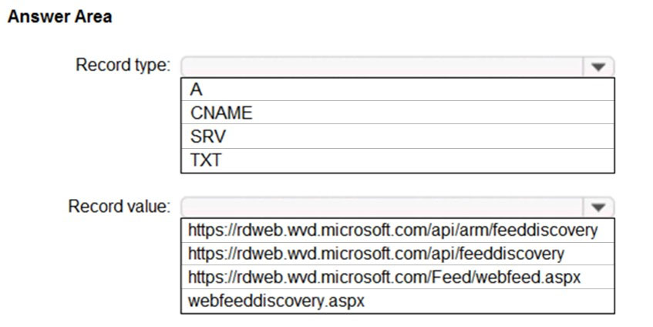

Answer:

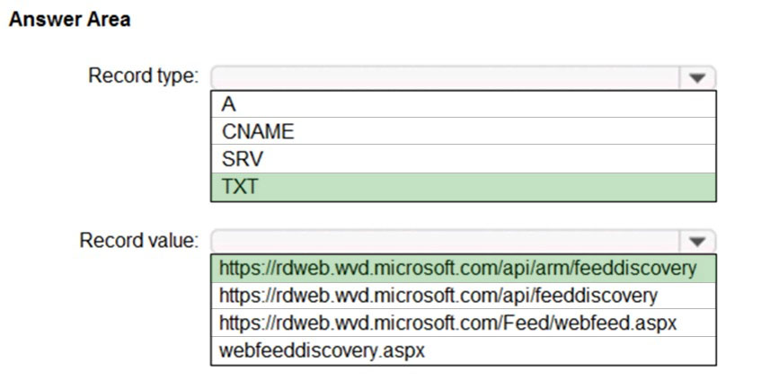

You have the devices shown in the following table.  
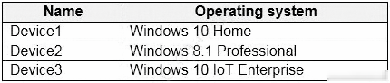  
You plan to deploy Azure Virtual Desktop for client access to remove virtualized apps.  
Which devices support the Remote Desktop client?

* A. Device1 and Device2 only
* B. Device1 and Device3 only
* C. Device1, Device2, and Device3
* D. Device1 only

Answer: B

You plan to deploy Azure Virtual Desktop.  
Users have the devices shown in the following table.  
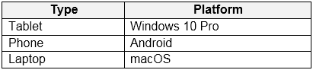  
From which device types can the users connect to Azure Virtual Desktop resources by using the Remote Desktop client app and the Remote Desktop web client?  
To answer, select the appropriate options in the answer area.  
NOTE: Each correct selection is worth one point.  
Hot Area:  
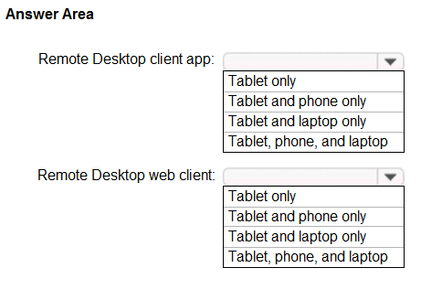

Answer:

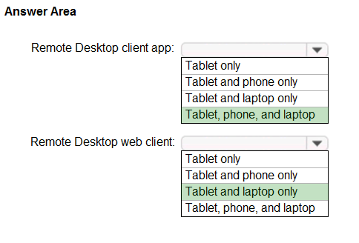

You are designing an Azure Virtual Desktop deployment.  
You identify the network latency between the locations where users reside and the planned deployment.  
What should you use to identify the best Azure region to deploy the host pool?

* A. Azure Traffic Manager
* B. Azure Virtual Desktop Experience Estimator
* C. Azure Monitor for Azure Virtual Desktop
* D. Azure Advisor

Answer: B

Your company has 60,000 users.  
You plan to deploy Azure Virtual Desktop.  
You need to recommend a storage solution for the FSLogix profile containers. The solution must provide the highest possible IOPS and the lowest latency desktop experience.  
What should you recommend?

* A. Azure Data Lake Storage
* B. Azure NetApp Files
* C. Azure Blob Storage Premium
* D. Azure Files Standard

Answer: B

Your network contains an on-premises Active Directory domain that syncs to an Azure Active Directory (Azure AD) tenant. The domain contains the domain controllers shown in the following table.  
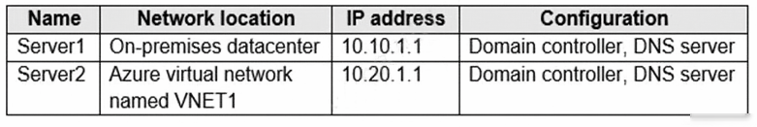  
The DNS servers are configured to forward requests to an external DNS service.  
You create a new virtual network named VNET2 that is peered to VNET1 and has gateway transit enabled.  
You plan to implement an Azure Virtual Desktop host pool in VNET2. The session hosts will be joined to the Active Directory domain.  
You need to configure DNS to meet the following requirements:  
✑ Ensure that Azure Virtual Desktop users can resolve on-premises servers and Azure resources.  
✑ Ensure that azure Virtual Desktop remains operational if a DNS server fails.  
✑ Minimize administrative effort.  
What should you configure?

* A. the DNS settings of VNET2 to use Server2 and Server1
* B. the DNS settings of VNET2 to use the Azure DNS service
* C. the DNS settings of the virtual machines to use Server2 and Server1
* D. the DNS settings of the virtual machines to use the Azure DNS service

Answer: C

You have the Azure Virtual Desktop deployment shown in the following table.  
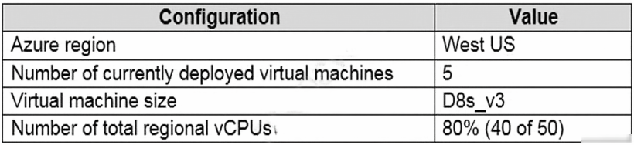  
You plan to deploy a new host pool as shown in the following table.  
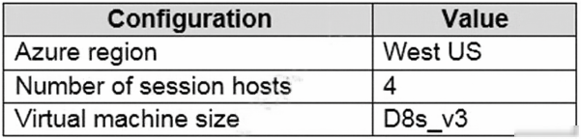  
You need to ensure that you can deploy the host pool.  
What should you do?

* A. Add a lock to the existing host pool.
* B. Stop and deallocate one of the currently deployed virtual machines.
* C. Submit a support request for service and subscription limits.
* D. Change the proposed virtual machine size for the session hosts to D4s_v3.

Answer: C

Note: This question is part of a series of questions that present the same scenario. Each question in the series contains a unique solution that might meet the stated goals. Some question sets might have more than one correct solution, while others might not have a correct solution.  
After you answer a question in this section, you will NOT be able to return to it. As a result, these questions will not appear in the review screen.  
You have an Azure Virtual Desktop host pool that contains five session hosts. The session hosts run Windows 10 Enterprise multi-session.  
You need to prevent users from accessing the internet from Azure Virtual Desktop sessions. The session hosts must be allowed to access all the required  
Microsoft services.  
Solution: You configure the RDP Properties of the host pool.  
Does this meet the goal?

* A. Yes
* B. No

Answer: B  
The correct to modify the NSG on the network to prevent outgoing traffic

You deploy an Azure Virtual Desktop host pool named Pool1.  
You have an Azure Storage account named store1 that stores FSLogix profile containers in a share named profiles.  
You need to configure the path to the storage containers for the session hosts.  
Which path should you use?

* A. \\store1.blob.core.windows.net\profiles
* B. https://store1.file.core.windows.net/profiles
* C. \\store1.file.core.windows.net\profiles
* D. https://store1.blob.core.windows.net/profiles

Answer: C

You have a Azure Virtual Desktop host pool that has a max session limit of 15. Disconnected sessions are signed out immediately.  
The session hosts for the host pool are shown in the following exhibit.  
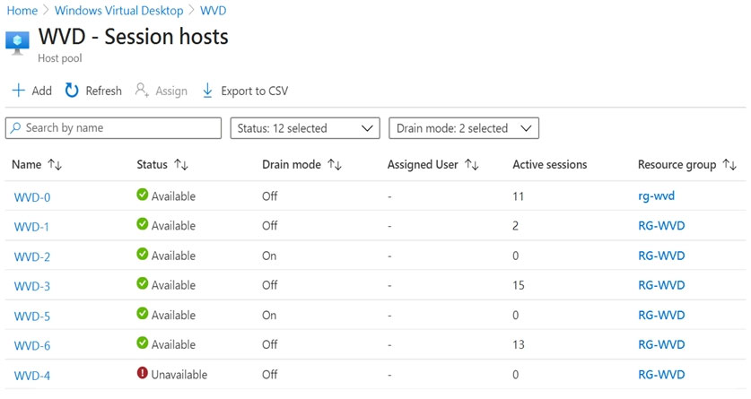  
Use the drop-down menus to select the answer choice that completes each statement based on the information presented in the graphic.  
NOTE: Each correct selection is worth one point.  
Hot Area:  
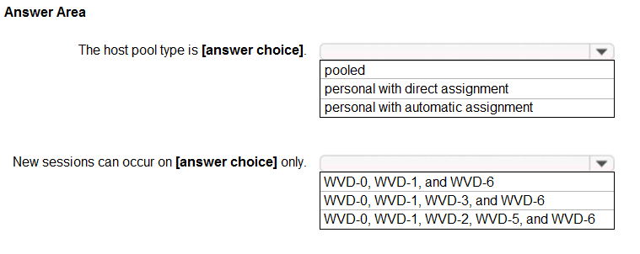

Answer:  
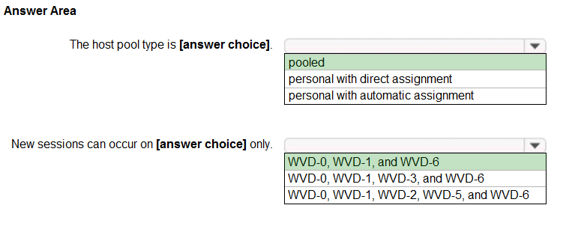  
-pooled

-0-1-6 (take a look in Drain Mode in OFF)

You have an Azure virtual machine named VM1 that runs Windows 10 Enterprise multi-session.  
You plan to add language packs to VM1 and create a custom image of VM1 for an Azure Virtual Desktop host pool.  
You need to ensure that modern apps can use the additional language packs when you deploy session hosts by using the custom image.  
Which command should you run first? To answer, select the appropriate options in the answer area.  
NOTE: Each correct selection is worth one point.  
Hot Area:  
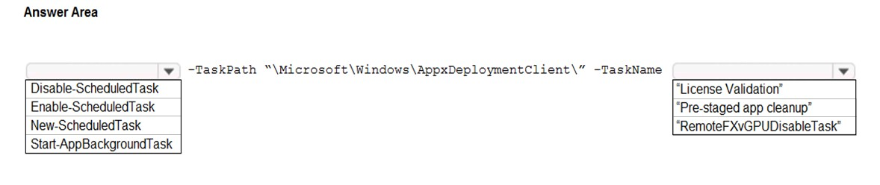

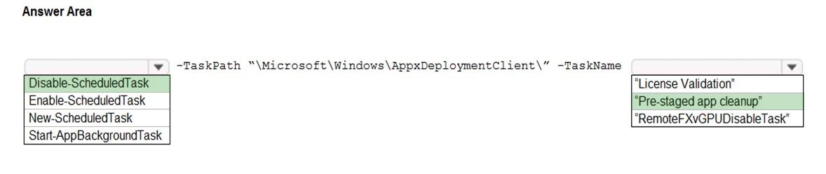

https://docs.microsoft.com/en-us/azure/virtual-desktop/language-packs

Create a custom Windows 10 Enterprise multi-session image automatically.

If you'd rather install languages through an automated process, you can set up a script in PowerShell...

##Disable Language Pack Cleanup##

Disable-ScheduledTask -TaskPath "\Microsoft\Windows\AppxDeploymentClient\" -TaskName "Pre-staged app cleanup"

You have a Azure Virtual Desktop deployment.  
You have a session host named Host1 that has the disk layout shown in the exhibit. (Click the Exhibit tab.)  
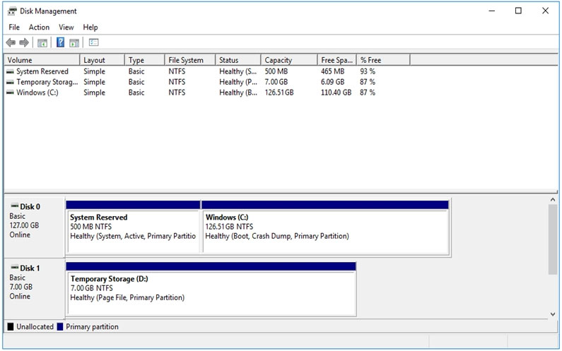  
You plan to deploy an app that must be installed on D. The app requires 500 GB of disk space.  
You need to add a new data disk that will be assigned the drive letter D. The solution must maintain the current performance of Host1.  
Which four actions should you perform in sequence? To answer, move the appropriate actions from the list of actions to the answer area and arrange them in the correct order.  
Select and Place:  
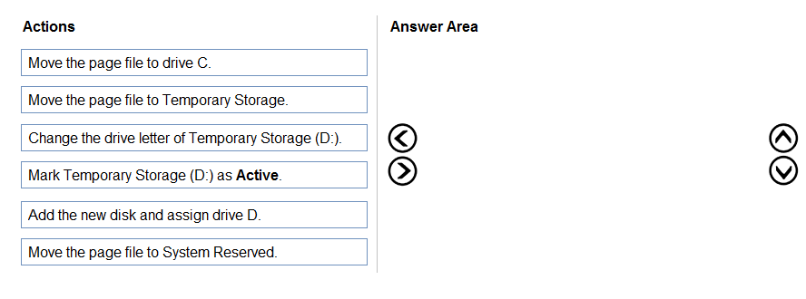

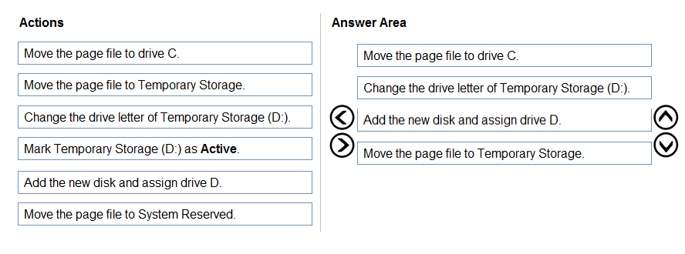

1. First, you need to move page file from Temporary Storage, since this will block drive letter change
2. Then change Temporary Storage to other than D:
3. Assign letter D: to newly created storage
4. Finally, move page file back to Temporary Storage

You plan to deploy Azure Virtual Desktop session host virtual machines based on a preconfigured master image. The master image will be stored in a shared image gallery.  
You create a virtual machine named Image1 to use as the master image. You install applications and apply configuration changes to Image1.  
You need to ensure that the new session host virtual machines created based on Image1 have unique names and security identifiers.  
What should you do on Image1 before you add the image to the shared image gallery?

* A. At a command prompt, run the set computername command.
* B. At a command prompt, run the sysprep command.
* C. From PowerShell, run the rename-computer cmdlet.
* D. From the lock screen of the Windows device, perform a Windows Autopilot Reset.

Answer: B

You have a shared image gallery that contains the Windows 10 images shown in the following table.  
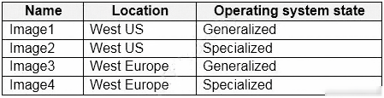  
You create an Azure Virtual Desktop deployment that has the following settings:  
  
Host pool name: Pool1 -  
  
✑ Location: West US  
✑ Host pool type: Personal  
Which images can you use for the session hosts?

* A. Image1 only
* B. Image1, Image2, Image3, and Image4
* C. Image2 only
* D. Image1 and Image2 only
* E. Image1 and Image3 only

Answer: E